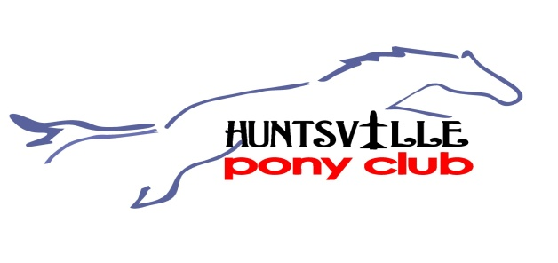
Huntsville Pony Club/Midsouth Region (#080350)
2019 Calendar of Events

January 12-13 Board Planning Meeting/Retreat @ BJ’s Lake Home, Crane Hill AL
30-3 USPC Annual Symposium & Convention, Louisville KY
27 Barngate @ Miyako Sushi Bar, 6pm

February 3 Winter Clinic w/ Katie Stoy @ River Pine Farm, Huntsville AL
4 Board Meeting @ Ruby Tuesday, South Huntsville AL 7pm
9 HPC Hands out lunches at Mooreland Hunt, Courtland AL
23 Midsouth Regional QUIZ Rally, Bowling Green KY

March 3 Unmounted Meeting @ River Pine Farm, Huntsville AL 2:30 pm-4:30 pm (mane pulling and clipping)
4 Board Meeting @ TBD, Huntsville AL 6:30pm
31 Ratings Prep @ River Pine Farm, Huntsville AL 2:30pm – 4:30pm (**Completed Work/Record Books Due**)

April 1 Board Meeting @ TBD, South Huntsville AL 6:30pm
14 Ratings Prep @ River Pine Farm, Huntsville AL 2:30 pm – 4:30 pm (***Workday for Parents***)
20 Midsouth Games Rally @ Butlers’ Bend Farm, Franklin TN
28 Spring Ratings @ River Pine Farm, Huntsville AL 8am-4pm
28 Rally Information and Commitment Meeting, River Pine Farm, Huntsville AL 5pm-6pm

May 4 AHJA Hunter/Jumper Show @ River Pine Farm, Huntsville AL
6 Board Meeting @ TBD, Huntsville AL @ 6:30pm.
19 Rally Prep Meeting @ River Pine Farm, Huntsville AL 2:30pm-4:30pm (WORK DAY FOR PARENTS)
28 Summer Jumper Night (#1 of 3) @ River Pine Farm, Huntsville AL 4:30pm (Rain Date June 4th)

June 3 Board Meeting @ TBD, South Huntsville AL 6:30pm
7-9 HPC Summer Camp @ River Pine Farm, Huntsville AL
11 Summer Jumper Night (#2 of 3) @ River Pine Farm, Huntsville AL 4:30pm (Rain Date June 13)
11 Rally Prep Session @ River Pine Farm, Huntsville, AL 10 am – 4 pm
16 Final Rally Prep Session @ River Pine Farm, Huntsville AL 2:30pm – 4:30pm
18-19 Midsouth Show Jumping Rally and D1 Rally @ Kentucky Horse Park, Lexington KY

July 1 Board Meeting @ TBD, Huntsville AL 6:30pm
9 Summer Jumper Night (#3 of 3) @ River Pine Farm, Huntsville AL 4:30pm (Rain Date 11 July)
21 Champs Prep and Load Trailer @ River Pine Farm, Huntsville AL 2:30-4:30 pm
24-28 USPC Champs East @ Tryon Int’l Equestrian Center, Mills Spring NC

August 3 Unload trailer from Champs, @ River Pine Farm
5 Board Meeting @ TBD, South Huntsville AL 6:30pm

September 10 Board Meeting @ TBD, South Huntsville AL 6:30pm
15 Ratings Prep @ River Pine Farm, Huntsville, AL @ 2:30-4:30 pm
27-29 Mounted Clinic w/ Dustin Durham @ River Pine Farm, Huntsville AL
29 Fall Ratings @ River Pine Farm, Huntsville AL

October 7 Board Meeting @ Ruby Tuesday, South Huntsville AL 7pm
20 Annual Meeting of Sponsors @ River Pine Farm, Huntsville AL 4:30pm
20 Work day @ River Pine Farm, Huntsville AL 2:30 – 4:30 pm
26-27 AHJA Hunter/Jumper Show and Schooling Show @ River Pine Farm, Huntsville AL

November 4 Board Meeting @ TBD, South Huntsville AL 6:30 pm
11 Ratings Prep @ River Pine Farm, Huntsville AL 2:30pm – 4:30pm
18 Fall Ratings @ River Pine Farm, Huntsville AL 8am

December 5 Board Meeting @ TBD, South Huntsville AL 6:30 pm
14-15 HPC Christmas Party @ Morgan’s Farm, Taft TN Revised 09/19/18

*All dates subject to change*

